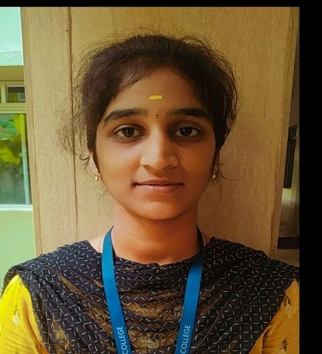

Kiruthiga.M,

103/55,paygopuram 4th street,

Tiruvannamalai-606601,

Tamilnadu,

India.

keethumano02@gmail.com

9025572971

# Career Objective

Seeking a challenging position in a reputed organization where I can learn new skills, expand my knowledge, and leverage my learning.

# Educational Qualifications

|  |  |  |  |  |
| --- | --- | --- | --- | --- |
| **Course** | **Name of the Institution** | **Board/ University** | **Year of Passing** | **MarksObtained** |
| Bachelor of Engineering (Computer Science) | Saveetha Engineering College,Thandalam,Chennai. | AnnaUniversity(Autonomous) | 2023 | (CGPA)9.23  (Till 6thsemester) |
| HSC | Sishya Matric  Hr Secondary School,  Tiruvannamalai.. | State Board | 2019 | 84.5% |
| SSLC | Mount Saint Joseph Matric higher Secondary School, Tiruvannamalai. | State Board | 2017 | 95.8% |

**Skill sets**

* Communication skills
* Creativity
* Time Management

**Technical Skills**

* Basics of C language
* Python
* Basics in JAVA

# Projects

# Mini project on “ONLINE RESTAURANT MANAGEMENT SYSTEM ”

# The main objective builds the system is to provide online ordering, saving time and reservation service online to the customer.

# Project on “ON ROAD VEHICLE ASSITANCE WEB PAGE”

# A web page for finding nearby mechanic shops. Registration and log in page using HTML,CSS.

# Workshop

* Attended workshop on Recent trends in AI and Machine Learning.
* Attended workshop on Bridging python with MYSQL.

**Extra-Curricular Activities**

* Actively participating in the National Level Quiz on “ARTIFICIAL INTELLIGENCE” conducted by Saveetha Engineering College, Thandalam, Chennai.

# Certificates

# Core Java

* Bridging python with MYSQL.

# Recent trends on artificial intelligence and machine learning.

**Internship**

* Completed 4 weeks online training on internship.

# Interests

# Cooking

# Painting

# Kabaddi

# Travelling

# Music

# Personal Information

Date of birth & Age : 12 March 2002 & 20

Gender : Female

Nationality : Indian

Languages Known : English (Professional Working),

Tamil (Native or Bilingual),